Assignment2 - Linear Factor Model

ChanJung Kim

October 29, 2018

1. The intercept coefficient and the slope coefficient of each industry derived from regression analysis

Table 1 Alpha and Beta for ten industries

|  |  |  |
| --- | --- | --- |
| Industry | Intercept(Alpha) | Slope(Beta) |
| NoDur | 0.369443 | 0.652647 |
| Durbl | -0.415599 | 1.648536 |
| Manuf | 0.159771 | 1.169846 |
| Enrgy | 0.501719 | 0.96985 |
| HiTec | -0.06402 | 1.132969 |
| Telcm | 0.194691 | 0.900729 |
| Shops | 0.275492 | 0.826492 |
| Hlth | 0.237841 | 0.673036 |
| Utils | 0.444585 | 0.538086 |
| Other | -0.387135 | 1.207309 |

By regressing the excess industry returns on the excess market returns, the intercept coefficients(alpha), and the slope coefficient(beta) can be derived as above table. For a passive portfolio, alpha usually means wrong pricing, whereas it denotes managers’ ability to outperform the market for an active portfolio. Beta implies the asset's sensitivity to systematic risk. The more sensitive an asset is to market risk, the higher beta it has. Therefore, people expect higher return from a high beta asset.

1. Security market line(SML) of betas and returns

Table 2 Mean return for market and ten industries

|  |  |
| --- | --- |
|  | Mean Return |
| NoDur | 0.902833 |
| Durbl | 0.733333 |
| Manuf | 1.012833 |
| Enrgy | 1.231167 |
| HiTec | 0.76625 |
| Telcm | 0.881417 |
| Shops | 0.916333 |
| Hlth | 0.783833 |
| Utils | 0.907167 |
| Other | 0.489083 |
| Market | 0.748083 |

Table 3 Y-intercept and slope for SML

|  |  |
| --- | --- |
| Y-intercept | 1.03277 |
| Slope | -0.18547 |

Figure 1 Security Market Line

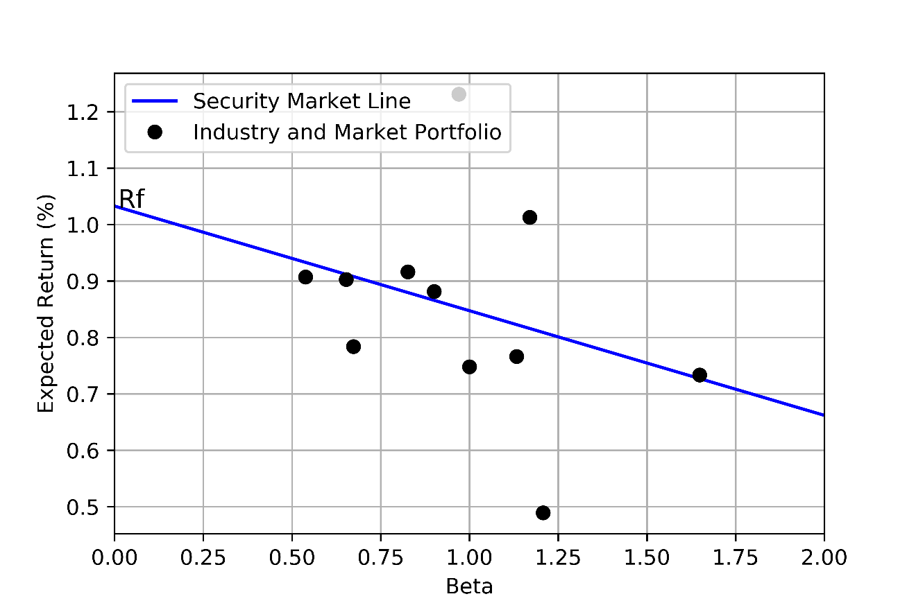

The SML represents the relationship between beta and expected return. The y-intercept is risk-free rate, whereas slope is the market premium. Even though it’s heading downward in this example, it has a positive slope in usual situations. A steep upward linear curve means that the risk premium is high. SML is very useful to identify undervalued and overvalued assets. If an asset is plotted above the line, it is undervalued, because investors can enjoy greater return than the market average. On the other hand, an asset below the line is overvalued, giving smaller return to the investors than the market expectation.